**<<< ARCADE GAMES>>>**

**Project Charter**

**Document Control**

**Document Information**

| **©** | **Information** |
| --- | --- |
| Document Id | Project Management Document #1 |
| Document Owner | Adag, Rey Emmanuel; Dy, Mileah Zoei; Godiez, Kent Vincent |
| Issue Date | May 4, 2025 |
| Last Saved Date | May 4, 2025 |
| File Name | Software Project Management Document |

**Document History**

| **Version** | **Issue Date** | **Changes** |
| --- | --- | --- |
| 1.0 | May 4, 2025 | Initial version of the document with all fields updated. It has not undergone changes since its completion. |
|  |  |  |
|  |  |  |
|  |  |  |

**Document Approvals**

| **Role** | **Name** | **Signature©** | **Date** |
| --- | --- | --- | --- |
| Team Lead | Godinez, Kent Vincent |  | May 4, 2025 |
| Product Lead© | Adag, Rey Emmanuel |  | May 4, 2025 |
| Tech Lead | Dy, Mileah Zoei |  | May 4, 2025 |

**Table of Contents**

**1 Executive Summary 2**

**Company 2**

**Project Name 2**

**Proposed Start Date 2**

**Proposed End Date 2**

**Preparer 2**

**Contact 2**

**2 Project Definition 2**

2.1 Vision 3

2.2 Objectives 3

2.3 Scope 3

2.4 Deliverables 4

**3 Project Organisation 5**

3.1 Customers 5

3.2 Stakeholders 5

3.3 Roles 5

3.4 Responsibilities 5

3.5 Structure 6

**4 Project Plan 8**

4.1 Approach 8

4.2 Overall Plan 9

4.3 Resource Plan 10

4.4 Financial Plan 10

4.5 Quality Plan 11

**5 Project Considerations 12**

5.1 Risks 12

5.2 Issues 12

5.3 Assumptions 13

5.4 Constraints 13

**6 Appendix 13**

6.1 Supporting Documentation© 13

# **Executive Summary**

| **Company** | Team 1 |
| --- | --- |
| **Project Name** | Arcade Game System |
| **Proposed Start Date** | January 30, 2025 |
| **Proposed End Date** | May 17, 2025 |
| **Preparer** | Dy, Mileah Zoei |
| **Contact** | 23101579@usc.edu.ph |

Arcade Games is an offline, multi-game PC application that combines three vintage arcade games—Space Invaders, Bomberman, and Pac-Man—into a single platform to give gamers a smooth and nostalgic gaming experience. The project will be developed by Kent Godinez (Team Lead), Rey Adag (Product Lead), and Mileah Dy (Tech Lead) over four main phases of development: planning, game development, user interface design, and testing and debugging. However, the system still holds several risks and issues, such as incomplete development, buggy systems, and graphic performance issues. Moreover, it assumes that the team is familiar with programming in Java, users understand the basics of classic arcade games and their mechanics, and the system will not require frequent updates or online connectivity. This project faces various constraints, such as requirement of standard keyboard and mouse inputs, availability of audio devices, local storage for leaderboards, and the short time limit placed on the project.

# **Project Definition**

Arcade Games is an offline, multi-game PC application that combines three vintage arcade games—Space Invaders, Bomberman, and Pac-Man—into a single platform to give gamers a smooth and nostalgic gaming experience. This software is designed to run without an internet connection, ensuring accessibility and uninterrupted gameplay. With a simple yet engaging interface, Arcade Games allows users to select and play any of the included games effortlessly, making it ideal for retro gaming enthusiasts and casual players alike.

The primary objective of Arcade Games is to revive the essence of classic arcade gaming while providing a modern, user-friendly platform that requires minimal setup. The inconvenience of downloading separate versions or putting up with pointless ads and in-game purchases that are frequently included in online alternatives is removed by combining several games into a single program. Furthermore, the application maintains each game's original pixel-art looks and physics, preserving the authenticity that retro gamers value. One of the software's primary benefits is that it offers a user-friendly, portable, and accessible gaming environment, which makes it perfect for gamers who wish to play for brief periods of time without being dependent on the internet. By enabling gamers to relive the heyday of arcade gaming, it also promotes nostalgia. In order to further improve the gaming experience, Arcade Games plans to add more games to its catalog, add high-score leaderboards, and add customization options like movable controllers and display settings.

Due to its offline gaming nature, the arcade games project will not include online multiplayer or cloud-based saving, simply relying on the locally saved leaderboard. The system is also limited to a desktop app, therefore not compatible with mobile devices.

## **Vision**

To relive the heyday of classic arcade games through a compact, accessible, and user-friendly centralized gaming hub

## **Objectives**

Business Objectives

* To collect and respond to at least 5 customer feedback during testing to implement improvements to the system before the final game release.
* To complete all game development and testing at least a week before the final output deadline.
* To minimize cost expenses by less than 20% of our estimates by conserving electricity and internet usage during development.

Technology Objectives

* To implement and design the three games (BomberMan, PacMan, and Space Invaders) as well as their user interface and menu navigation using object-oriented programming principles in Java to improve game runtime and optimize draw cycles to no more than 10 ms per cycle by the end of game development.
* To maintain a consistent frame rate of 60 FPS for at least 98% of gameplay duration during the testing phase.
* To implement a leaderboard system in a local file which can store up to 20 of the top player scores before the end of game development.
* To implement a fully functional keyboard input system that allows mapping of all in-game controls (movement, player action, pause) to any key code by the end of game development.

## **Scope**

The scope of the project includes:

* *Delivering at least 3 playable classic arcade-style games on the platform*
* *Implementing a localized leaderboard system*
* *Implementing a main menu interface to access game selection, settings, and leaderboard.*
* *Allowing player customizable settings and control remapping*
* *Implementing in-game pause, resume, and restart functionality*

The scope of the project will not include:

* *Online multiplayer*
* *Mobile or web versions*
* *Cloud-based saving of leaderboard*

## **Deliverables**

| **Item** | **Components©** | **Description** |
| --- | --- | --- |
| Game Launcher and Menus | * Main Menu UI * Game Select UI * Settings UI * Leaderboard View UI | * Navigation between system screens * Game selection and launch screen * Game settings screen for adjusting audio, user interface, and control remapping * View of leaderboard with top 20 player scores for each game |
| Game Titles | * BomberMan Game * PacMan Game * Space Invaders Game | * BomberMan is a top-down game where the player navigates a maze, places bombs to destroy obstacles, and eliminates enemies. The objective is to clear the stage by defeating all enemies without being caught in the blast radius or colliding with enemies. * PacMan is a top-down game where the player must move around the map to collect all pellets and power ups while avoiding enemies. The stage is cleared once all pellets and power ups are collected. * Space Invaders is a top-down game where the player must defeat a descending group of invaders before they reach the bottom of the screen. The stage is completed when the player shoots all enemies while avoiding being shot by them. |
| Leaderboard System | * Local file management * Rank system * Score calculator | * Local storage of player scores * Ranks top 20 player scores per game * Player score calculation based on game events and player actions |
| In-Game HUD | * Life Bar * Level Counter * Score Tracker * Power Up Indicator | * Player life counter which updates for every player life lost * Updates current level number * Tallies player score * Indicates whether power up is activated or not, and which power up is activated if the game has several power ups |
| Game Settings | * Audio Adjustment * Control Key Remapping * UI Theme Adjustment | * Adjust master volume percent, and toggle background music on or off * Allows user to remap basic controls to any key * Selection of dark mode or light mode for UI |

# **Project Organisation**

## **Customers**

| **Customer** | **Representative©** |
| --- | --- |
| Players | N/A |

## **Stakeholders**

| **Stakeholder©** | **Interested in** |
| --- | --- |
| Estose, Jude Vicris | Overall product output and completion |
| Nullar, Angelo Raymond |
| Paglinawan, Anjoe |

## **Roles**

| **Role** | **Organisation©** | **Resource Name** | **Assignment Status** | **Assignment Date** |
| --- | --- | --- | --- | --- |
| Team Lead | Team 1 | Godinez, Kent Vincent | Assigned | January 30, 2025 |
| Product Lead | Team 1 | Adag, Rey Emmanuel | Assigned | January 30, 2025 |
| Technical Lead | Team 1 | Dy, Mileah Zoei | Assigned | January 30, 2025 |
| Stakeholder | Team 8 | Estose, Jude Vicris | Assigned | January 30, 2025 |
| Stakeholder | Team 8 | Nullar, Angelo Raymond | Assigned | January 30, 2025 |
| Stakeholder | Team 8 | Paglinawan, Anjoe | Assigned | January 30, 2025 |
| Project Review Lead | University of San Carlos | Fabian, Elline | Assigned | January 30, 2025 |

## **Responsibilities**

**Team Lead**

A Team Lead undertakes all tasks involving overseeing the overall project, setting goals and objectives, and guiding team members. Key responsibilities include:

* Supervise overall project execution and team coordination
* Manage task allocations
* Monitor team performance and ensure productivity
* Creation and update of sprints
* Organize team meetings

**Product Lead**

The Product Lead is the main communicator with stakeholders. Key responsibilities include:

* Communication with stakeholders
* Verification of product functionalities and adjustments
* Coordinate play testing and feedback collection
* Ensure user and customer satisfaction

**Technical Lead**

The Technical Lead is responsible for managing and supervising technical decisions of the team when it comes to programming the software. Key responsibilities include:

* Oversee code practices, quality, and design methods used
* Review technical decisions and fix coding inconsistencies
* Ensure system performance and efficiency
* Compilation of code into a single program

**Project Review Lead**

The Project Review Lead is a 3rd party representative responsible for ensuring the progress of the project as according to plan

* Ensure key milestones, deliverables, and timelines are being met
* Regularly assess current project progress
* Identify any possible project risks or issues
* Recommend corrective actions and improvements based on reviews

**Stakeholder**

The Stakeholder is the client of the project. Key responsibilities include:

* Defining the functional and non-functional requirements, vision, and objectives of the project
* Approve any changes in scope or requirements
* Review final output and approve completion

## **Structure**

The organizational structure of the *Arcade Games* software project is designed to support effective project execution through clearly defined roles, responsibilities, and reporting relationships. The diagram below illustrates the formal hierarchy of the project, aligning each member with their corresponding responsibilities.

# 

At the top of the structure is the Project Review Lead, Engr. Elline Fabian, from the University of San Carlos. She provides oversight to ensure that the project is aligned with academic and professional standards, assessing progress, deliverables, and any risks throughout the project lifecycle.

Reporting to her are the Stakeholders from Team 8: Jude Vicris Estose, Angelo Raymond Nullar, and Anjoe Paglinawan. These individuals act as the clients of the project. They are responsible for defining the project's goals and requirements, reviewing output, and approving final deliverables.

Directly beneath the stakeholders is the Project Team — Team 1: Arcade Games — which executes the actual design, development, and delivery of the software product. This team is composed of:

* **Rey Emmanuel Adag**, the **Product Lead**, who serves as the liaison between the development team and stakeholders, ensuring the final product meets the intended requirements and user expectations.
* **Mileah Zoei Dy**, the **Technical Lead**, who supervises technical implementation, programming quality, and system efficiency.
* **Kent Vincent Godinez**, the **Team Lead**, who manages project execution, coordinates tasks, monitors timelines, and guides the team to ensure on-time and quality delivery.

This structure promotes accountability, enables consistent communication between stakeholders and developers, and ensures that each function of the project is handled by a designated leader with relevant responsibilities. It also reflects the collaborative nature of academic software projects while maintaining clarity in roles and reporting lines.

# **Project Plan**

## **Approach**

| **Phase** | **Approach©** |
| --- | --- |
| Planning | Discuss software requirements and product output with clients. Create and plan the design patterns and architecture to be used in programming the software. |
| Game Development | Develop the main game modules (BomberMan, PacMan, Space Invaders) and their basic gameplay functions. |
| User Interface (UI) Design | Integrate an interactive user interface for seamless system navigation, as well as leaderboard and customization settings. |
| Testing and Debugging | Conduct alpha and beta testing. Implement updates and revisions based on feedback. |

## **Overall Plan**

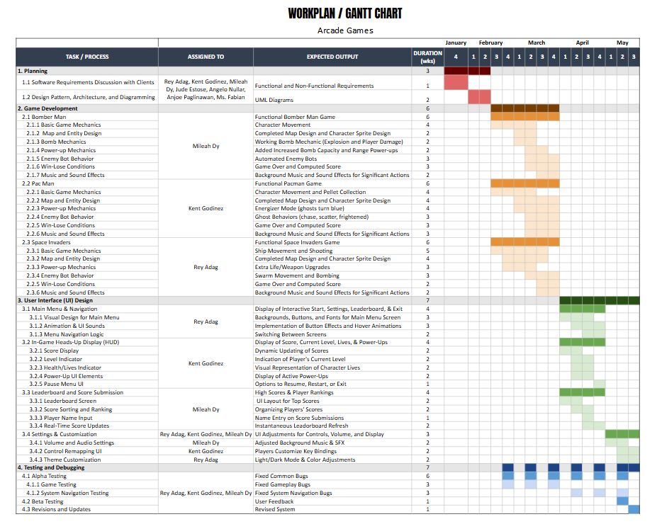

**Milestones**

| **Milestone** | **Date©** | **Description** |
| --- | --- | --- |
| Finalized Software Requirements | 01/31/2025 | Defines the whole system’s vision and requirements, therefore setting the goals and proper scope of the project. |
| All Game Modules Completed | 03/31/2025 | The game modules (BomberMan, PacMan, Space Invaders) are the vital portion of the system. Without them, the main goals of the project would not be completed. |
| User Interface and Navigation Menus Implemented | 04/30/2025 | Enhances user appeal and immersion, and creates a high-quality environment. |
| Tested and Revised Game | 05/11/2025 | Ensures a stable output with any bugs or issues already removed to improve user experience. |

**Dependencies**

| **Project Activity** | **Impacts on** | **Impacted on by** | **Criticality©** | **Date** |
| --- | --- | --- | --- | --- |
| Implement Keyboard Controls | Gameplay Experience | Availability of Input Devices (Keyboard) | High | Feb . 1-15, 2025 |
| Add Audio Functionality | Immersive User Experience | Audio Output Devices Procurement | Medium | Feb. 16-29, 2025 |
| Develop Leaderboard System | Game Score Tracking | Local File System Permissions | Medium | Mar. 1-15, 2025 |
| Design Menu Interface | Navigation Usability | UI/UX Team Asset Delivery | Low | Mar. 16-30, 2025 |
| Optimize for Windows | System Compatibility | Windows OS Version Testing | High | Apr. 1-15, 2025 |

## **Resource Plan**

| **Role** | **Start Date** | **End Date** | **% Effort** |
| --- | --- | --- | --- |
| Team Lead | 01/03/2025 | 05/17/2025 | 100% |
| Product Lead | 01/03/2025 | 05/17/2025 | 100% |
| Technical Lead | 01/03/2025 | 05/17/2025 | 100% |
| Project Review Lead | 01/03/2025 | 05/17/2025 | 18% |
| Stakeholder | 01/03/2025 | 05/17/2025 | 18% |

## **Financial Plan**

| **Category** | **Cost©** | **Value** |
| --- | --- | --- |
| Materials and Equipment | * All-In-One Desktop PC (3x) | *₱ 105,000.00* |
| Miscellaneous | * Food Expenses * Electricity * Wifi | *₱ 100,800.00*  *₱ 20,000.00*  *₱ 12,000.00* |
| Marketing | * Advertising and promotional materials | *₱ 5,000.00* |

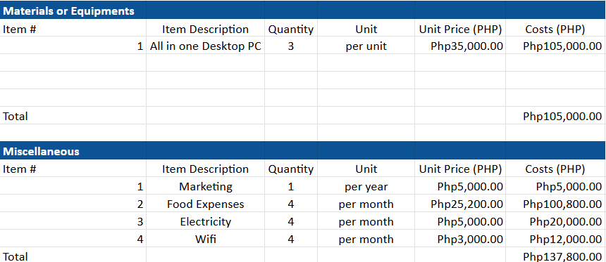



## **Quality Plan**

| **Process©** | **Description** |
| --- | --- |
| Quality Management | Regular code reviews, automated testing, and user acceptance testing (UAT) to ensure deliverables meet specifications |
| Change Management | Document changes and confirm them with clients through the Product Lead |
| Risk Management | Identify possible risks beforehand during planning phase to apply best practices and mitigate any risks |
| Issue Management | Keep track of any issues and resolve problems according to severity |
| Configuration Management | Keep track of all versions of the game files (code, art, docs) so nothing gets lost or overwritten. This can be done using Github. |
| Document Management | Compile relevant documents on a shared document space using Google Docs |
| Acceptance Management | Ensure each deliverable meets output criteria based on requirements provided by stakeholders |
| Procurement Management | Plan purchases (e.g., sound effects, paid assets) and compare free alternatives first. |
| Financial Management | Track expenditures to ensure they are within budget as documented in financial plan |
| Timesheet Management | Objective recording of human resource allocation for equitable contribution assessment. (Using Google Docs still) |
| Project Reporting | Provide weekly updates on project progress and any issues which need to be resolved |
| Project Communications | Utilize communication platforms (Facebook, Messenger, Google Chats) and conduct team meetings occasionally. |

# **Project Considerations**

## **Risks**

| **Description** | **Likelihood** | **Impact©** | **Mitigating Actions** |
| --- | --- | --- | --- |
| Inability to finish full game development within the set time limit | Medium | Very High | Focus on core features and implement fair distribution of responsibilities |
| Buggy game system | Medium | High | Regular debugging and testing, and usage of organized code design |
| Graphics performance issues and frame drops | Low | Low | Apply efficient code practice and optimize draw cycles |

## **Issues**

| **Description©** | **Priority** | **Resolution Actions** |
| --- | --- | --- |
| Limited time to complete game system, resulting in simplified and game mechanics which are not as polished | High | Maximize time and focus on development of major game mechanics |
| Inconsistent player collision which results in unclear visuals and unfair gameplay | Medium | Improve boundary box detection methods |
| Unorganized code and occasional application of bad practice to rush code output | Medium | Optimize code design and architecture, and make use of object-oriented programming principles |

## **Assumptions**

The major assumptions identified with the project include:

* Team has experience in Java and object-oriented programming development
* Users have basic familiarity with classic arcade games and their mechanics.
* The application will be used primarily for entertainment purposes.
* The system will not require frequent updates or online connectivity.
* The hardware on which the application runs will meet the minimum requirements for smooth gameplay.
* No changes will be made to the scope when finalizing the product

## **Constraints**

The major constraints identified with the project include:

* The system relies on standard input devices such as a keyboard and mouse.
* The application depends on the availability of audio output devices for sound effects and music.
* The leaderboard system is limited to storing data locally, so it does not depend on external databases or cloud services.
* Project is time-bound to only a few months, limiting the possible quality of system features.

# **Appendix**

## **Supporting Documentation**©

* Work Plan and Financial Plan spreadsheet: <https://docs.google.com/spreadsheets/d/1Q8C7B4cisqQKnhdavD4dQ4vXMvIivcNhvgeTYGICRTc/edit?usp=sharing>